18.80: a) 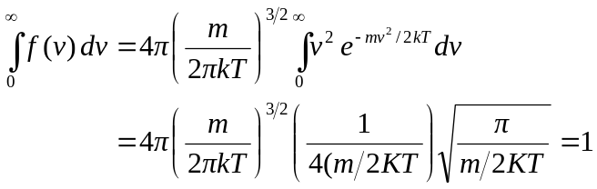

where the tabulated integral (given in Problem18.81) has been used. b) 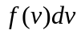 is the probability that a particle has speed between 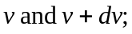the probability that the particle has some speed is unity, so the sum (integral) of 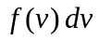must be 1.

